(EN)

Fake News ‘Fake news’ is the heartfelt cry of politicians who feel wronged by the online media. Ad blocking and filter bubbles have made consumers and voters harder to reach. Industrial scale behavioral profiling and viral marketing via Twitter bots are a new method to so do. The expansion of social networking and smartphones means that new methods of communication are necessary, and consumers-voters are filtering out content they do not like. That is not new—it applied to the tabloid newspapers methods of ‘yellow’ journalism, radio news and telegraph-supplied newswires 100 years ago. Unfortunately, the failure to adopt a universal independent public service model then meant the public was inflamed by irresponsible media into a series of wars for the first time made global by the same communications means (telegraphs, railways, radio, long-distance reliable air and maritime transport) that enabled the mass media. Today, the calls for fake news regulation pay no regard to both historians of technology and legal historians who can advise on public service media. Twitter and Facebook offer parallels to Hearst newspapers and radio broadcasts. It is high time for an interdisciplinary project exploring how to avoid the same disastrous outcomes. Computer technology is a tool for the powerful; that insight is not new but politicians are ignoring the previous generations of transformative technology and our attempts to marshal them. More obviously, politicians are not fully using the tools of behavioral insight to explore how to regulate fake news and social networking: evolutionary economics and behavioral neuroscience tells us how we become addicted to social media, yet legislators are only beginning to consult the experts to explore how social networking affects our behavior in fundamental ways.6 Social and economic sciences, as well as computer scientists, and neuroscientist, can help lawyers convince legislators not to be silly.

<https://www.lexisnexis.com/communities/corporatecounselnewsletter/b/newsletter/archive/2017/09/08/a-little-truth-about-fake-news-and-the-law.aspx>

<https://www.legalzoom.com/articles/fake-news-what-laws-are-designed-to-protect>

Just a few years ago, “fake news" was something you'd find in supermarket tabloids.

Now, though, the line between “fake news" and “real news" can seem awfully blurry. “Fake news" has been blamed for everything from swaying the U.S. presidential election to prompting a [man to open fire](https://www.nytimes.com/2016/12/05/business/media/comet-ping-pong-pizza-shooting-fake-news-consequences.html?_r=0) at a Washington, DC pizza parlor.

**What's Fake and What's Real?**

A “real news" outlet, such as a major newspaper or television network, might make mistakes, but it doesn't distribute false information on purpose. Reporters and editors who report real news have a code of ethics that includes using reputable sources, checking facts, and getting comments from people on both sides of an issue.

Fake news outlets, on the other hand, are designed to deceive. They might have URLs that sound like legitimate news organizations, and they might even copy other news sites' design. They may invent “news" stories or republish stories from other internet sources without checking to see if they are true. Their purpose is usually to get “clicks" and [generate ad revenue](https://www.legalzoom.com/articles/navigating-your-online-advertising-agreement) or to promote their owners' political viewpoint.

Some “fake news" is published on satire sites that are usually clearly labeled as satire. However, when people share articles without reading beyond the headline, a story that was supposed to be a parody can end up being taken as the truth.

**Can't the Legal System Punish Fake News?**

The First Amendment protects Americans' rights to freely exchange ideas—even false or controversial ones. If the government passed laws outlawing fake news, that would be censorship that would also have a chilling effect on real news that people disagree with.

The main legal recourse against fake news is a [defamation lawsuit](https://www.legalzoom.com/articles/differences-between-defamation-slander-and-libel). You can sue someone for defamation if they published a false fact about you and you suffered some sort of damage as a result—such as a lost job, a decline in revenue, or a tarnished reputation. If you are an ordinary, private person, you also must show that the news outlet was negligent (or careless).

But most fake news relates to public figures, who can only win a defamation lawsuit by showing that the news outlet acted with “actual malice." This means that the author must have known the story was false or must have had a “reckless disregard" for whether it was true or not. It's usually a difficult standard to meet, but defamation suits may become more common as concern about fake news grows.

For example, Chobani yogurt recently [filed a defamation suit](http://www.huffingtonpost.com/entry/chobani-sues-alex-jones-fake-news_us_58feaec6e4b06b9cb9198b65) against conspiracy theorist Alex Jones and his site, Infowars, over a video and tweet headlined “Idaho Yogurt Maker Caught Importing Migrant Rapists." Jones' tweet led to a boycott of the popular yogurt brand.

Defamation liability isn't limited to the person who first published a fake story—it extends to anyone who republishes it on a website or blog. Melania Trump, for example, recently settled defamation lawsuits against a [Maryland blogger](https://www.washingtonpost.com/local/public-safety/melania-trump-reaches-settlement-in-libel-lawsuit-against-maryland-blogger/2017/02/07/3b8ecd86-ed3e-11e6-9973-c5efb7ccfb0d_story.html?utm_term=.8e9b67c81deb), who published an article in August 2016, and the online Daily Mail that published a similar false article later that month.

**How to Spot Fake News and Stop it from Spreading**

Fake news can be hard to identify, with some fake news sites looking and sounding almost exactly like well-known media outlets. Here are some tips for figuring out what's fake and what's real:

* **Read beyond the headline.**The article may be labeled as a parody or it may just sound too outlandish to be true.
* **Check the story out** on Snopes.com, which has been researching rumors and false stories for two decades. For political news, try FactCheck.org.
* **See if the story comes from one of these**[fake news websites](http://www.politifact.com/punditfact/article/2017/apr/20/politifacts-guide-fake-news-websites-and-what-they/) identified by PolitiFact.com as part of a collaborative effort with Facebook.
* **Fact check the story yourself.**Do an online search to confirm the main facts in the story, click on any links provided, and read the sources. Also look for any reports identifying the site as a fake news site, and/or look up the author's bio online.

In the end, the law can't protect you from fake news. Get your news from sources that you know are reputable, do your research, and read beyond the headlines. And, if you find out an article is fake, don't share it. That's the surest way to stop a false story from spreading.

*An article, image or other form of content that is knowingly false or fabricated, that is then distributed via the internet, especially via social media, with the intention of:*

1. *Swaying opinion, sparking emotion or even causing outrage among individuals who—believing the information to be true—click, comment and/or spread the information and/or take some form of action that supports a particular cause or point of view*
2. *Getting the reader to click through the content, driving “click revenue,” and view and even click on web ads, driving more click revenue and, potentially, purchases*

However you define it, fake news has always been around. When you think about it, we already had a perfectly fine word in “propaganda,” used most infamously and with murderous effect by Adolf Hitler’s Minister of Propaganda, Joseph Goebbels. Like many things with the internet, however, it’s all about magnitude—the incredible efficiency, the global reach and the thick wall of anonymity that social media and the web have enabled. You used to have to work hard to find a guy’s mugshot. Now, practically anyone in the world can find it with a mere Google® search, as well as many photos of his dog, Shiloh, reclining in a beret and jaunty scarf.

“Fake news—whether you accept our definition or another—can go back 2,500 years, some scholars say,” writes LexisNexis’ **Korinne Bressler** in a post titled [*The Evolution of Fake News*](https://www.lexisnexis.com/communities/lexisnexis_biz/b/bizblog/archive/2017/07/13/the-evolution-of-fake-news.aspx)*.* “But if you think of fake news as something that is intentionally false and widely distributed, and your goal is to spark some sort of societal change in line with your beliefs, there is a more definitive date,” she wrote. “The real birth of fake news … coincided with the invention of the Gutenberg Press in 1439, which made it possible for news accounts to be published and circulated widely with no thought of journalistic integrity.”

Since the internet and social media have made content distribution and sharing fast and cheap, information is coming at us through multiple firehoses. “All of this digital information has brought yellow journalism back to the forefront. With so much information out there, it’s often hard to stay on top of which stories are true or not,” Bressler writes.

Bressler goes on to chronicle some landmark events in the sordid history of fake news, including one from 1755 when the Catholic Church and other European authorities said only sinners were killed in the devastating Lisbon earthquake that year. “It was reported,” Bressler noted, “that the Virgin Mary saved everyone else.”

For word junkies, Merriam-Webster® writes in a post titled [*The Real Story of “Fake News”*](https://www.merriam-webster.com/words-at-play/the-real-story-of-fake-news) that while the dissemination of spurious news isn’t new, “the term *fake news* is”—“new” being a relative term. “*Fake news* appears to have begun seeing general use at the end of the 19th century,” according to *Merriam-Webster.com*, which offered this headline: “Secretary Brunnell Declares Fake News About His People is Being Telegraphed Over the Country. —*Cincinnati Commercial Tribune* (Cincinnati, OH), 7 June 1890.”

**When “Fake News” is Real News**

  In a recent article titled [*Fake News: A Legal Perspective*](https://papers.ssrn.com/sol3/papers.cfm?abstract_id=2958790), published in the *Journal of Internet Law*, **David O. Klein** and **Joshua R. Wueller** of Klein Moynihan Turco LLP, caution that the definition itself is experiencing some fakery: “In recent months, a number of politicians and public figures have repurposed the phrase ‘fake news’ to describe reports from traditional news publishers that they dislike or find unflattering … However, traditional news publications fall squarely outside of our definition of ‘fake news’ because they are not intentionally or knowingly false in nature.”

To illustrate 21st Century fake news, Klein and Wueller recounted one of the most infamous episodes—infamous because it sparked actual violence, while also being sad and ridiculous. “Pizzagate” involved an entirely fake and aggressively bizarre tale, which originated at a fake news factory in Macedonia, about a fictitious child sex trafficking ring purportedly operated by then-presidential candidate Hillary Clinton and other Democrats. This fictional enterprise was said to be operated out of a Washington, D.C., pizza shop called, of all things, Comet Ping Pong. This perverse fable spread like wildfire via social media, sparking so much rage in a North Carolina man that he drove to Comet Ping Pong with an assault rifle and revolver to investigate.  He fired several shots in the pizzeria, but, finding no enslaved children, this itinerant vigilante surrendered to the police. He is currently serving a four-year prison sentence.

**Claims & Causes of Action**

In their review of legal claims used to combat fake news, Klein and Wueller discuss the following in some detail: civil actions for defamation, intentional infliction of emotional distress, as well as intellectual property violations, and other speech-related torts, such as false light invasion of privacy, fraud, tortious interference, and unfair and deceptive trade practices. “Fake news publishers have also been on the receiving end of claims of regulatory violations in the areas of unfair and deceptive trade practices, criminal libel, and cyberbullying,” Klein and Wueller write.

“In 2012,” they add, “the Supreme Court in *United States v. Alvarez*invalidated the federal *Stolen Valor Act of 2005*, which criminalized falsely representing oneself as having been awarded military medals or decorations. Favoring counter-speech and refutation over government regulation of false speech, the court held that interest in truthful discourse alone was insufficient to sustain the criminal statute at issue.”

“As media attention and public condemnation of fake news continues to intensify,” the Klein Moynihan Turco attorneys write, “we predict that more lawmakers, regulators, courts and private citizens will explore legal and regulatory solutions that balance the societal importance of truth-seeking with the constitutional right to speak freely (and, at times, to lie).” Download a PDF of their article [here](https://papers.ssrn.com/sol3/papers.cfm?abstract_id=2958790).

**In the meantime, what can be done?**

**Eric P. Robinson** is an attorney and Assistant Professor of Journalism at the University of South Carolina. He blogs at [bloglawonline.com](http://bloglawonline.com/). In a recent post, [*Fake News is a Real Dilemma for the Law*](http://bloglawonline.blogspot.com/2017/02/fake-news-is-real-dilemma-for-law.html), he says it is “all but impossible” to prevent the release of fake news. “The U.S. Supreme Court has held that such prior restraints are allowed only in the most extraordinary circumstances, such as when the information reveals national security information,” Robinson writes. “But even that is construed narrowly, with the court holding that the government could not stop *The New York Times*® and other newspapers from publishing the Pentagon Papers, a classified history of our involvement in Vietnam, even as the war there was still going on. In another case that did not reach the Supreme Court, a federal judge barred publication of an article detailing in the inner workings of the hydrogen bomb.

“So if ‘fake news’ cannot be barred from publication, what can be done legally after it is published? Likely, not much,” Robinson writes. “That is because it’s difficult to sue unless the false information actually harms someone: by hurting their reputation, invading their privacy or causing another harm such as emotional distress.”

<https://vpchothuegoldenking.com/sk/why-do-we-believe-in-fake-news/>

Žijeme v dobe prebytku najrôznejšíchinformácie. Dnes je ťažké predstaviť si človeka, ktorý o falošných správach nič nepočul. Anglické slovo fake sa prekladá ako falošný, falošný. Ale ako pochopiť, ktoré správy sú pravdivé a ktoré nie? Dánski vedci Vincent Hendricks a Pelle Hansen nazývajú obdobie falošných správ „informačnou búrkou“ alebo informačnou búrkou. Je to však skutočne dôvod, prečo mnohí veria falošným informáciám iba v príbehoch o ľudskej hlúposti a neprimeranosti? Skúsme to zistiť.

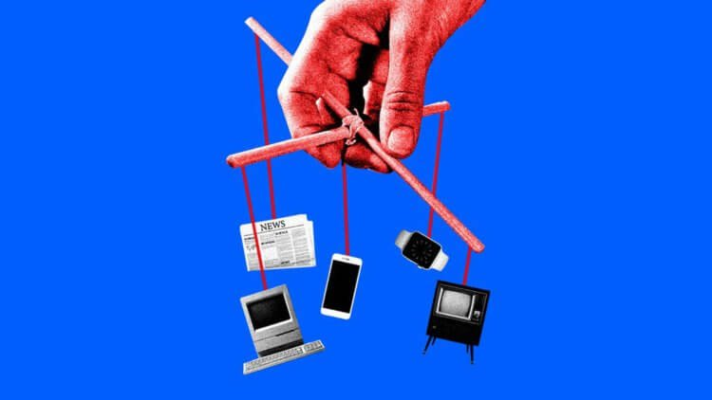

Veľké množstvo informácií sťažuje hľadanie skutočných informácií.

Čo sú falošné správy?

Falošné, to znamená, falošné, falošné správy -sú to informácie alebo informačný produkt, ktorý obsahuje čiastočne alebo úplne žiadne pravdivé informácie. V minulosti sa falošné správy, ktoré boli vytlačené v novinách, nazývali „kačica“. Ich vlastnosťou bolo vždy to, že sa šírili neuveriteľne rýchlo.

Keby však novinové kačice boli často obyčajnou vecou alebo boli zámerne distribuované, falošné správy sa dnes nachádzajú dokonca aj v najrešpektovanejších médiách.

Prečo veríme falošným správam?

Podľa Hendricks a Hansen, keď nemámedostatok informácií na to, aby sme videli celý obraz, alebo ak nechceme nič skontrolovať alebo na to nie je čas, pozeráme sa na reakciu ostatných. Je logické, že keď o ničom nevieme, máme záujem dozvedieť sa názory tých, ktorí sú nám blízki. Vedci tvrdia, že osobné presvedčenie ostatných môže často naznačovať, čo sa v skutočnosti deje. Najmä ak veríme, že naše prostredie je v konkrétnej otázke dobre oboznámené. Nezabudnite však, že nie všetci ľudia z nášho prostredia sú odborníkmi na všetky problémy.

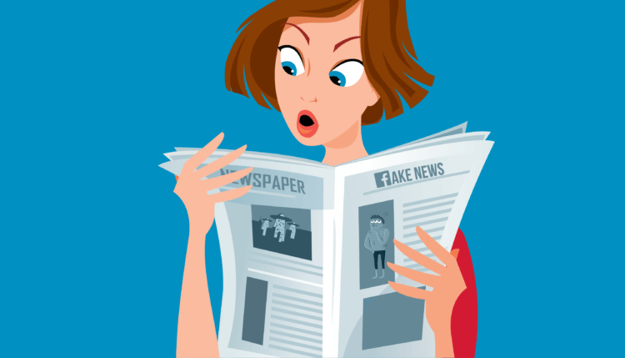

V minulosti bolo ľahšie pochopiť, ktoré správy sú „kačica“ a ktoré nie.

Odborníci sa domnievajú, že dôvodom dôvery vfalošné správy možno spočívajú v skutočnosti, že dnes mnohí nerozumejú spôsobu distribúcie informácií na internete. A nekontrolujte fakty. Aké ďalšie dôvody veríte v dôveryhodnosť falošných správ? Tieto a ďalšie naliehavé problémy týkajúce sa falošných správ môžete diskutovať v našom telegramovom rozhovore.

Ako pochopiť, že vám hovoria pravdu?

Najlepší spôsob riešenia falošných správvedci označujú schopnosť kriticky myslieť. Pripomeňme, že kritické myslenie je spôsob myslenia, pri ktorom sa človek pýta nielen na svoje presvedčenie, ale aj na akékoľvek prichádzajúce informácie. Dnešné falošné správy sa však natoľko zmenili, že ani odborníci v médiách nedokážu vždy rozlíšiť pravdu od fikcie.

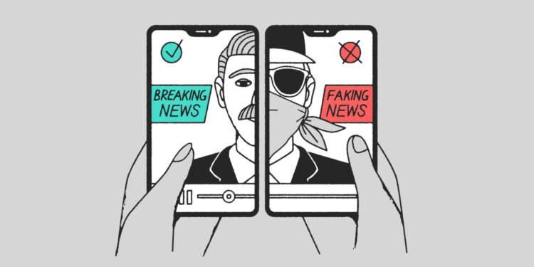

Sociálne siete postupne menia problém falošných správ na hrozbu

Situácia sa zhoršila s príchodom spoločnostisiete. Dnes môžu všetci zdieľať akékoľvek informácie so svojimi priateľmi. Takže môžete prísť s akýmkoľvek príbehom, ktorý sa vám páči, pridať k nemu nejaké skutočné udalosti a odovzdať ho v nominálnej hodnote. A sociálne siete sa často používajú ako spôsob, ako budovať a prilákať publikum. Čím hlasnejšie a jasnejšie správy, tým viac ľudí príde na vašu stránku. To nás vedie k nasledujúcej metóde, ktorá nám umožňuje rozlíšiť pravdivé informácie od nepravdivých informácií - falošné správy sa často „strieľa“ - to znamená, že lietajú okamžite cez sociálne siete.

Je to zaujímavé: NVIDIA učila umelou inteligenciu vytvárať falošné videá

Dôvodom je, že priemerný čitateľ bude pravdepodobne chýbať obvyklým správam o kultúre a ekonómii, ale určite sledujte spojenie s chytľavým a neštandardným nadpisom.

Čitatelia milujú zaujímavé príbehy.pomoc a tvorcovia falošných správ prichádzajú. Preto si pozorne prečítajte titulky. A nezabudnite sa prihlásiť na odber nášho kanála v Yandex.Zen, kde nájdete iba overené informácie.

Informácie samozrejme skontrolujte. Najlepšie je robiť to vždy. Áno, hľadanie zdroja vyžaduje určitý čas, ale ak dôležité informácie, ktoré vás upútali, nevzbudzujú dôveru, viete, čo máte robiť.

Overujete informácie alebo dôverujete názorom ostatných?

(SK)

Falošné správy „Falošné správy“ sú srdečnými výkrikmi politikov, ktorí sa cítia online médiami zle. Blokovanie reklám a filtračné bubliny sťažili prístup k spotrebiteľom a voličom. Profilovanie správania v priemyselnom meradle a vírusový marketing prostredníctvom robotov Twitter sú novou metódou. Rozšírenie sociálnych sietí a smartfónov znamená, že sú potrebné nové spôsoby komunikácie a spotrebitelia-voliči odfiltrujú obsah, ktorý sa mu nepáči. Nie je to nič nové - uplatňovalo sa na metódy bulvárnej noviny, „žltej“ žurnalistiky, rozhlasových správ a telegrafných novín pred 100 rokmi. Žiaľ, neprijatie univerzálneho nezávislého modelu verejnej služby potom znamenalo, že nezodpovedné médiá zapálili verejnosť po prvýkrát, keď sa globálne prvýkrát stali rovnakými komunikačnými prostriedkami (telegrafy, železnice, rádio, spoľahlivé vzdušné diaľky a námorná doprava), ktorá umožnila masmédiá. Výzvy na falošnú reguláciu správ dnes neberú ohľad ani na historikov technológie, ani na zákonných historikov, ktorí môžu poskytovať poradenstvo v médiách verejnej služby. Twitter a Facebook ponúkajú paralely novinám Hearst a rozhlasovým vysielaním. Je najvyšší čas na interdisciplinárny projekt, ktorý skúma, ako sa vyhnúť rovnakým katastrofickým výsledkom. Počítačová technológia je nástroj pre výkonných; tento náhľad nie je nový, ale politici ignorujú predchádzajúce generácie transformačnej technológie a naše pokusy o ich zosadenie. Je zrejmé, že politici v plnej miere nevyužívajú nástroje behaviorálneho prehľadu, aby preskúmali, ako regulovať falošné správy a sociálne siete: evolučná ekonómia a behaviorálna neuroveda nám hovorí, ako sme závislí od sociálnych médií, avšak zákonodarcovia sa začínajú radiť s odborníkmi, aby preskúmali ako sociálne siete ovplyvňujú naše správanie základnými spôsobmi.6 Sociálne a ekonomické vedy, ako aj počítačoví vedci a neurovedci, môžu právnikom pomôcť presvedčiť zákonodarcov, aby neboli hlúpi.

**BODY K FAKE NEWS**

* čo sú to falošné správy
* (kedy začali vznikať?)
* aký je rozdiel medzi falošnými a reálnymi správami, resp. zdroje, ktoré ich publikujú a ich zámer
* čo je to „behavioral profiling“ a „social networking“
* prečo vznikajú falošné správy, ako sa šíria
* resp. prečo to je dnes väčší problém, vývoj sociálnych sieti a uľahčenie zdieľania informácii
* aký majú dopad
* právny vzťah ku falošným správam
* možnosti reparácie, normy ošetrujúce tento problém

**OBRÁZKY K FAKE NEWS**

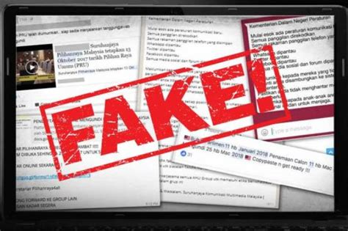

<https://external-content.duckduckgo.com/iu/?u=https%3A%2F%2Ftse1.mm.bing.net%2Fth%3Fid%3DOIP.4RUYddc_KIfFoOcN7USmyQHaE7%26pid%3DApi&f=1>

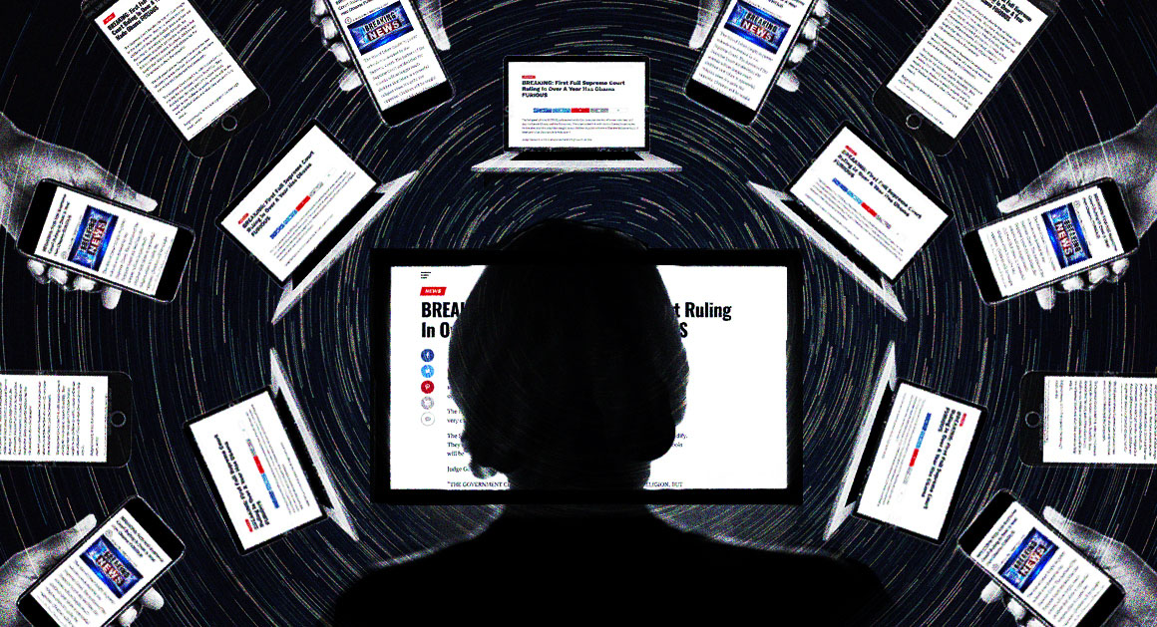

<https://external-content.duckduckgo.com/iu/?u=https%3A%2F%2Fstatic.politico.com%2Fe4%2F14%2Fe311b4914251a2a8ba7e09ea787c%2F180507-viral-illo-politico-illustration-istock-1160.jpg&f=1&nofb=1>

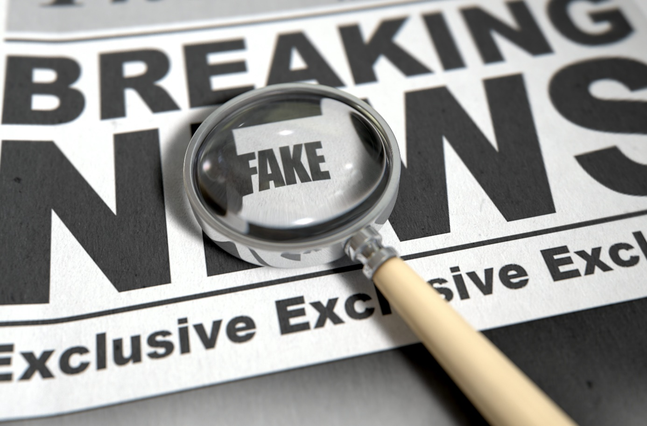

<https://external-content.duckduckgo.com/iu/?u=https%3A%2F%2Fwww.legalzoom.com%2Fsites%2Flegalzoom.com%2Ffiles%2Fuploaded%2Farticles%2Ffakenews.jpg&f=1&nofb=1>

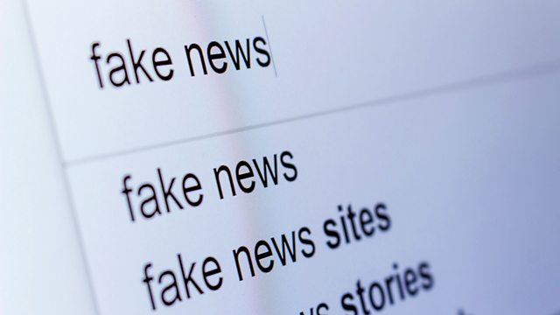

<https://external-content.duckduckgo.com/iu/?u=https%3A%2F%2Fichef.bbci.co.uk%2Fimages%2Fic%2F640x360%2Fp04xfr4m.jpg&f=1&nofb=1>

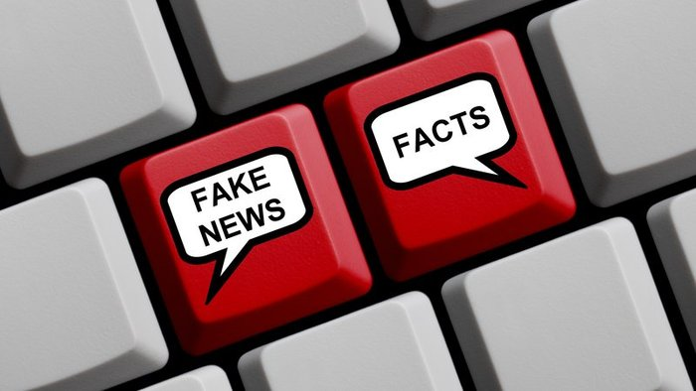

<https://static.markiza.sk/media/a501/image/file/21/0826/D2J0.fake_news_jpg.jpg>



<https://touchit.sk/wp-content/uploads/2016/12/FalosneSpravyFB.jpg>



<https://vpchothuegoldenking.com/wp-content/uploads/2019/09/5cdfc37c9479aefac349ca11e8d142ac.jpg>

(EN)

Platform Regulation Politicians ask: What is the difference between platforms and networks? Journalists confuse their readers by referring to all those companies as ISPs—even though access networks perform fundamental and entirely different functions than social networks or search engines. This is the canard thrown into the Net neutrality debate by those telcos. If we are regulated, they argue, the same should also apply to the giant monopolies of Google, Apple, Facebook, and Amazon (known collectively as ‘GAFA’). The very high public profiles of Twitter and Snap cause issues, as they are by no means monopolies. Google was fined €2.4billion by the European Commission in June 2017 for antitrust violations because of the links between its search engine and shopping platform. Google avoided an adverse outcome for eight years, a delay even longer than Microsoft under European investigation (a complaint in 1998 resulted in enforcement from 2004: Case T-201/04). E-commerce dominated by the GAFA platforms is becoming a major Heroic policy interventions by government often fail, especially when aimed at industry self-regulation. JANUARY 2018 | VOL. 61 | NO. 1 | COMMUNICATIONS OF THE ACM 31 viewpoints political issue especially in Europe, where mass youth unemployment and a rapidly ageing workforce means IT skills are in short supply, especially in Parliaments. Google- or Uber-sponsored promises of untold riches from autonomous vehicles fall on politicians’ deaf ears: robots do not vote. This is a red flag to those advising governments as well as those legislating.2 If platform regulation signals a desire to slow down the pace of innovation by government, what rational answer can be sold to government? The first essential is to prevent platforms becoming liable as publishers, by whatever legitimate means necessary. That may mean fines for failure to take down fake content or revenge porn. It may mean a user ombudsman as suggested in new proposed English legislation. Recruiting more internal content checkers at Facebook and Google to remove content may be overdue. Global platforms need to conform to European rules on hate speech (for instance Nazi content), a legal battle lost by Yahoo! in the French Tribunal de Grand Instance 17 years ago.b Co-Regulation as a Hybrid Solution What more can be done? Europe sets the global standards for regulation of content, notably in data protection and hate speech. The decisive power relationship in European law has swung to Germany and France. Regulation will increase, and Anglo-American companies increasingly recognize that and are embracing a French term: co-regulation. What that means is diluting government control of the Internet by ensuring a compromise based on industry self-regulation, but with oversight by users and by government regulators.3 Examples include global Top Level domain name oversight. Governments have sponsored industry standards not only in Europe but globally via hosting and supporting the World Wide Web Consortium with industry. Co-regulation is the compromise computer scientists must live with. Totalitarian regimes want to use the b Confirmed in Yahoo! Inc. v. La Ligue Contre Le Racisme et L’antisemitisme. L’Union Des Etudiants Juifs De France, 433 F.3d 1199 (9th Cir. 2006); http://bit.ly/2f8Oi59 threat of terrorism and cyber-crime to replace self-regulation with direct and often draconian control. Co-regulation is the best alternative. Areas for cooperation between law and computer science can flourish in co-regulatory institutions, because the best of them engineer a deliberative evidence-driven expert-friendly process.5 It can curb the worst excesses of both corporate and government control. If lawyers and computer scientists cooperate to make these social regulation processes work, it is the best chance to prevent a much worse system of direct government control emerging.

(SK)

Regulácia platformy Politici sa pýtajú: Aký je rozdiel medzi platformami a sieťami? Novinári zmiasť svojich čitateľov odkazom na všetky tieto spoločnosti ako na poskytovateľov internetových služieb - hoci prístupové siete vykonávajú základné a úplne odlišné funkcie ako sociálne siete alebo vyhľadávacie nástroje. Toto je kačica uvrhnutá do debaty o neutralite siete týmito telekmi. Ak sme regulovaní, tvrdia, že to isté by sa malo vzťahovať aj na obrovské monopoly spoločnosti Google, Apple, Facebook a Amazon (ďalej spoločne známe ako „GAFA“). Veľmi vysoké verejné profily služieb Twitter a Snap spôsobujú problémy, pretože v žiadnom prípade nie sú monopolmi. Európska komisia dostala v júni 2017 Európskej komisii pokutu vo výške 2,4 miliardy EUR za porušenie antitrustových pravidiel z dôvodu prepojení medzi jej vyhľadávacím nástrojom a nákupnou platformou. Spoločnosť Google sa podľa európskeho vyšetrovania vyhla nepriaznivému výsledku počas ôsmich rokov, čo je omeškanie dlhšie ako Microsoft (sťažnosť v roku 1998 viedla k vymáhaniu od roku 2004: vec T-201/04). Elektronický obchod, ktorému dominujú platformy GAFA, sa stáva hlavným zásahom vlády do politiky v oblasti hrdinstva, najmä keď je zameraný na samoreguláciu priemyslu. JANUÁR 2018 | VOL. 61 | NO. 1 | KOMUNIKÁCIA ACM 31 z politického hľadiska, najmä v Európe, kde masová nezamestnanosť mladých ľudí a rýchlo starnúca pracovná sila znamenajú nedostatok zručností v oblasti IT, najmä v parlamentoch. Sľuby nevýslovného bohatstva autonómnych vozidiel sponzorované spoločnosťou Google alebo Uber dopadajú na hluché uši politikov: roboti nehlasujú. Toto je červená zástava pre tých, ktorí poskytujú poradenstvo vládam, ako aj pre zákonodarcov.2 Ak regulácia platformy signalizuje túžbu spomaliť tempo inovácie zo strany vlády, akú racionálnu odpoveď možno vláde predať? Prvým nevyhnutným je zabrániť tomu, aby sa platformy stali zodpovednými za vydavateľov akýmkoľvek legitímnym spôsobom, ktorý je potrebný. To môže znamenať pokuty za nezrušenie falošného obsahu alebo pomstu porno. Môže to znamenať užívateľského ombudsmana, ako sa navrhuje v nových navrhovaných anglických právnych predpisoch. Nábor ďalších interných kontrolórov obsahu na Facebooku a Google na odstránenie obsahu môže byť oneskorený. Globálne platformy musia spĺňať európske pravidlá týkajúce sa nenávistných prejavov (napríklad nacizeného obsahu), čo je právna bitka, ktorú Yahoo! prehrala. vo Francúzskom tribunáli de Grand Instance pred 17 rokmi.b Koregulácia ako hybridné riešenie Čo viac sa dá urobiť? Európa stanovuje globálne normy pre reguláciu obsahu, najmä v oblasti ochrany údajov a nenávistných prejavov. Rozhodujúce mocenské vzťahy v európskom práve sa prehnali do Nemecka a Francúzska. Regulácia sa zvýši a angloamerické spoločnosti to čoraz viac uznávajú a zahŕňajú francúzsky pojem: koregulácia. To znamená, že oslabuje vládnu kontrolu nad internetom zabezpečením kompromisu založeného na samoregulácii odvetvia, ale pod dohľadom používateľov a vládnych regulátorov.3 Medzi príklady patrí globálny dohľad nad názvami domén najvyššej úrovne. Vlády sponzorovali priemyselné štandardy nielen v Európe, ale celosvetovo prostredníctvom hosťovania a podpory konzorcia World Wide Web Consortium s priemyslom. Koregulácia je kompromisný počítačový vedec, s ktorým musia žiť. Totalitné režimy chcú používať b Potvrdené v Yahoo! Inc. proti. La Ligue Contre Le Racisme et L'antisemitisme. L'Union Des Etudiants Juifs De France, 433 F.3d 1199 (9. cirk. 2006); http://bit.ly/2f8Oi59 hrozba terorizmu a počítačovej kriminality, ktorá nahradí samoreguláciu priamou a často drakonickou kontrolou. Koregulácia je najlepšou alternatívou. V koregulačných inštitúciách môžu prekvitať oblasti spolupráce medzi zákonom a počítačovou vedou, pretože tí najlepší z nich pripravujú proces orientovaný na expertízu orientovaný na dôkazné dôkazy.5 Môže obmedziť najhoršie excesy podnikovej a vládnej kontroly. Ak právnici a počítačoví vedci spolupracujú pri fungovaní týchto procesov sociálnej regulácie, je to najlepšia šanca zabrániť vzniku oveľa horšieho systému priamej vládnej kontroly.